MY VALUES ARE WORTHY
Nowadays all of us forget the importance of values especially young people. Thanks to this project, We will remind them the values.

GOALS

- Foreign language skill development
- Increasing students’ interest, motivation and participation
- Lifelong learning
- Enhancing cultural awareness and creativity
- Remembering forgotten values
- Enhancing the use of the technology-supported teaching environments and Web 2.0 tools.
- Intercultural communication

PROJECT PROMOTION VIDEO

Our project promotion video in 4 different languages, prepared with our project partners.

MENTIMETER
We asked our students which values you would like to study.
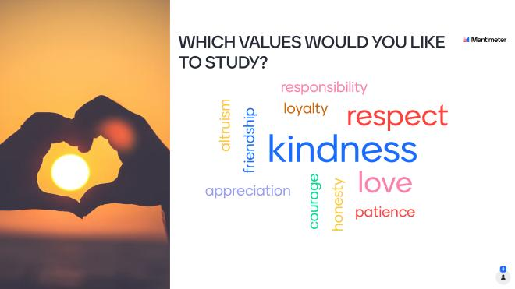

OUR TEAMS

WE USED KEAMK TO BUILD OUR TEAMS.

TEAM LOVE - RESPECT | TEAM FRIENDSHIP -JUSTICE | TEAM HONESTY- SELF CONTROL
YAĞMUR | CATALİN | ALEXANDRA
CARİNA | GİORGİ | NIKOLOZ K
ESİLANUR | NUPELDA | NİSA
RABİA | GÖKTUĞ | DAVİT
RODİCA

TEAM PATIENCE- RESPONSIBILITY | TEAM PATRIOTISM- ALTRUISM
CİHAN SUDE | ELİF
SESİLİ | MADALINA
ANDREEA | NIKOLOZ S.
ÖZLEM AFRA | HALİM

MATCHING ACTIVITY
The average scores of the students in the teams will be calculated and the first team will be determined.

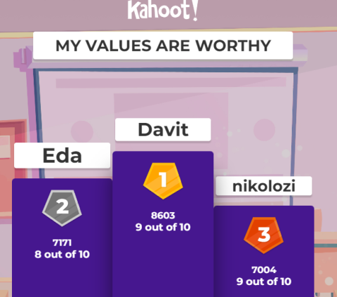

MAKE A WORDART ABOUT VALUES

What does the word values tell you ? Can you do and share a work on wordart related to values? Please write the words you use by translating them from your language to English. We will use WORD ART web.2 tool.
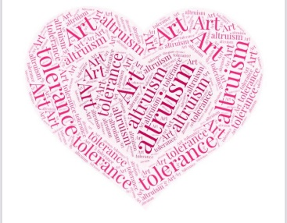
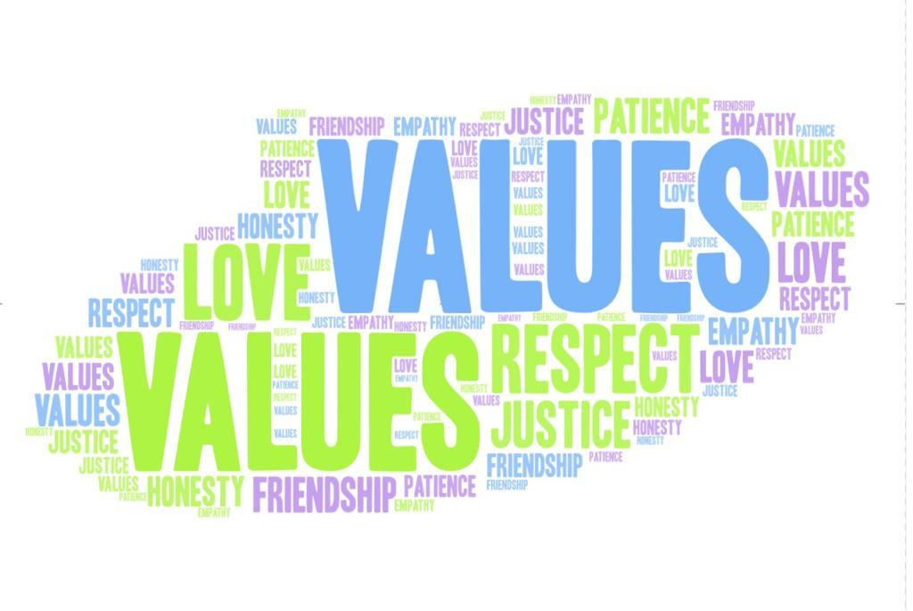

WORD HUNT
We made a puzzle using the wordart you create with the words that come to you when you say values. you will complete the puzzle and add the screenshot and write the words you see. We will use THE WORD SEARCH web.2 tool.

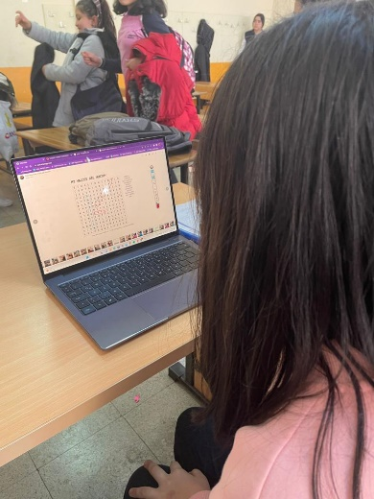
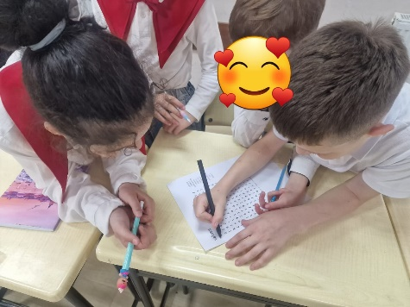
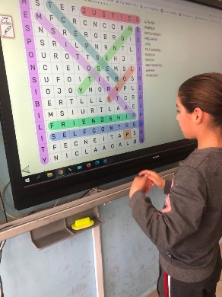

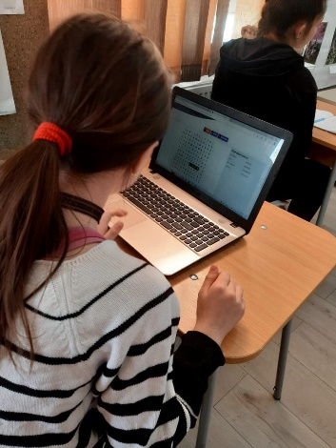

MAKE YOUR OWN VALUE QUOTE

Write your own value quote using the Quozıo web.2 tool, selecting a value you see in the word hunt puzzle.

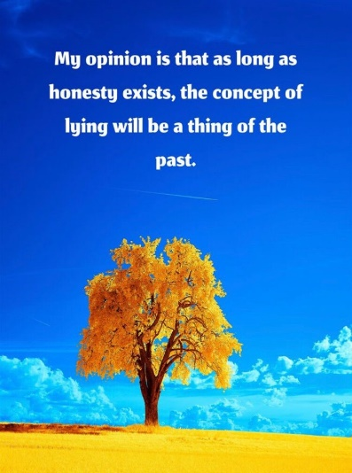
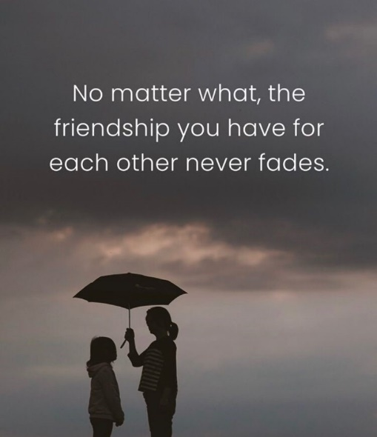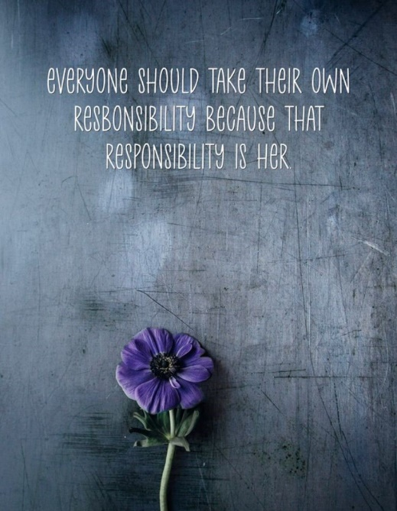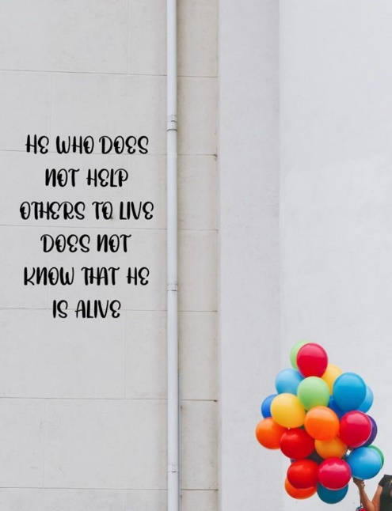

LOVE- RESPECT TEAM
Hello everybody. You know that we created 5 different mixed teams. We gave the 10 most desired values on the goals page to five different teams equally. Each team needs to study two values. Boxes called “Respect and Love Boxes” are placed in the classrooms. The Respect Box is introduced to the students and the project is explained. Stories, newspaper clippings, poems, essays, articles, etc. about love and respect from students. They are asked to find written material. (They can also write themselves.) Materials are sent to members of the love and respect team. Our love and respect team will broadcast podcasts about these two values using material from their friends using the VOCAROO web.2 tool and the online voice recorder web.2 tool.

https://padlet.com/e_twinningg/love-respect-team-fuj2mprhnnv61lal

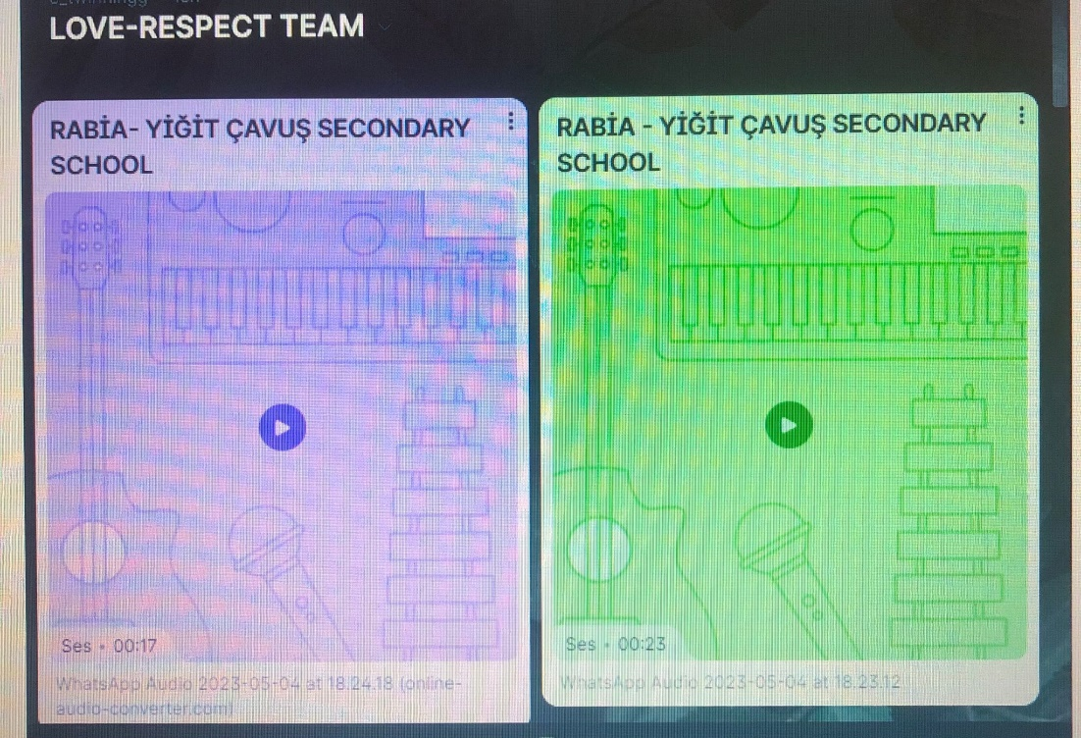

FRIENDSHIP - JUSTICE TEAM

The teacher chats with the students about the rules at the beginning of the lesson. He then tells the students that they will prepare a friendship constitution. The teacher asks the children what qualities a true friend should have. He takes the answers from them and writes all the suggestions on the board. After the students, he adds his own suggestions. Then, the teacher submits all qualifications to a vote. Qualifications for which more than half of the class says “yes” are selected for inclusion in the friendship constitution (the teacher must also vote on the rules he or she has written). All the rules are voted on and the teacher reads a good friend's qualifications before finalizing the constitution. Ask if anyone has any objections or suggestions in the class. Constitutions made in partner schools are collected by our friendship and justice team and our friendship and justice team will create an online newspaper using the Smore WEB.2 tool related to these two values.

https://www.smore.com/4ejmn

HONESTY - SELF CONTROL TEAM
Our honesty and self-control team has prepared a wordwall game. WE PLAYED HONESTY-SELF CONTROL WORDWALL GAME.

ALEXANDRA - 1. 2. 3. QUESTIONS
NIKOLOZ K - 4. 5. QUESTIONS
DAVİT - 6. 7. - QUESTIONS
NİSA- 8. 9. 10. - QUESTIONS
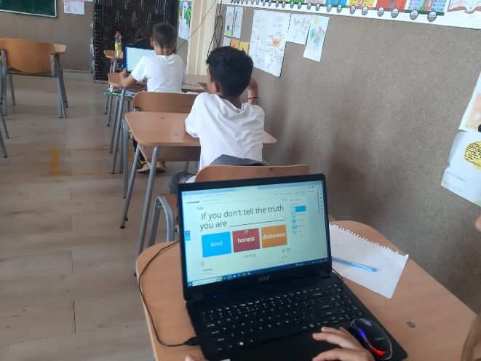
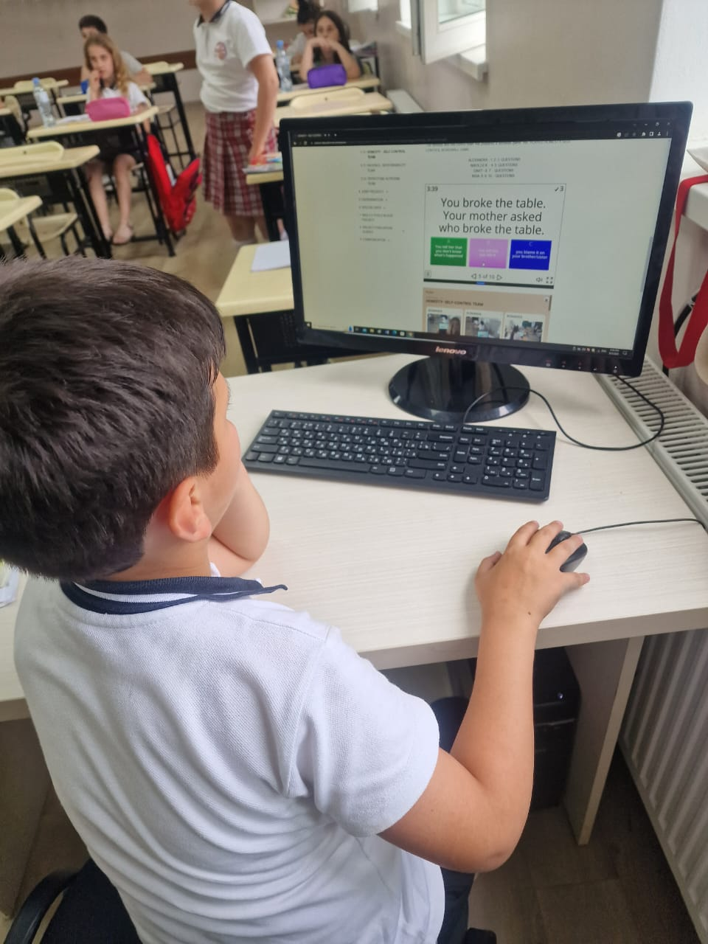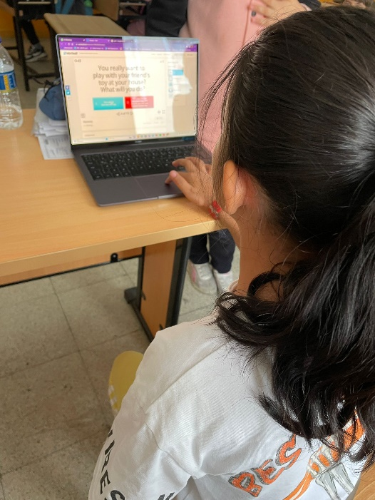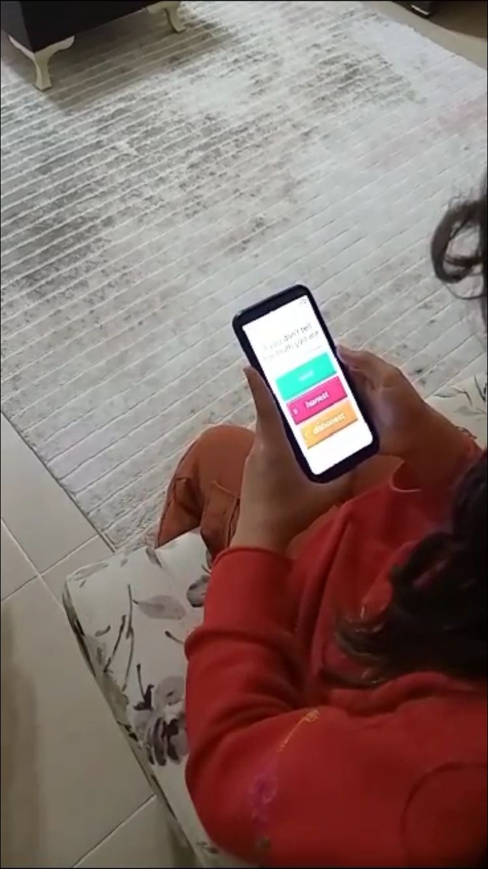

PATIENCE- RESPONSIBILITY TEAM
MY FLOWER I WILL GROW IT WITH PATIENCE.

We will patiently look at a flower for one month with our students taking part in the project. The students will share all the responsibilities of the flower equally between them. Our "patience and responsibility team" will collect the images of the flowers we looked for over a month and prepare a video for the Mother's Day, using the images of these flowers. Our team will use the VivaVideo web.2 tool while preparing the video.
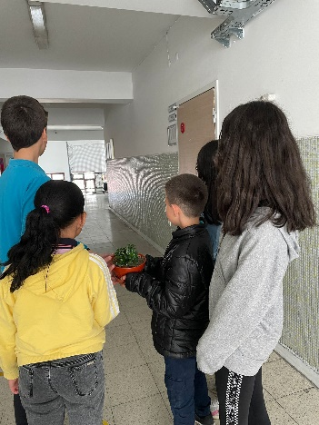
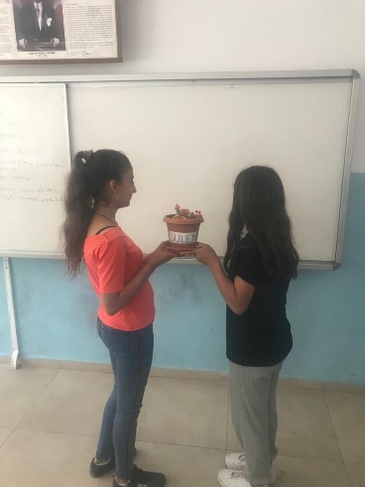
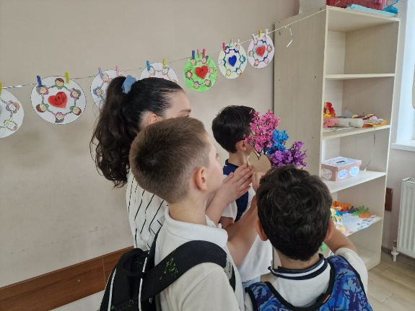

PATRIOTISM- ALTRUISM TEAM

In order to realize that the value of patriotism requires making altruism for the state, this activity has been developed to enable students to realize that making altruism when necessary is related to the value of patriotism. Our students will creatively prepare their country flags on the board. Inside this flag, they will give information about the people who made altruism for their country.
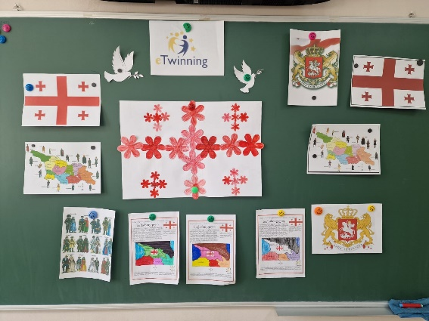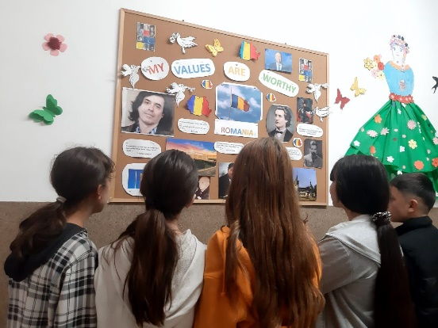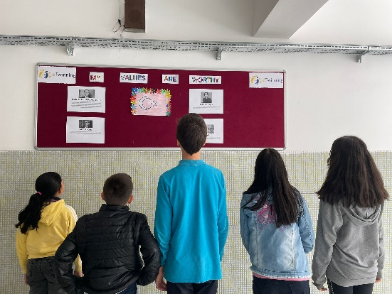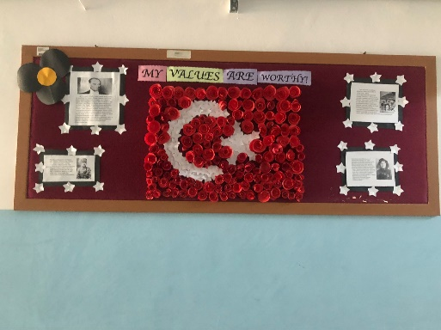

FINAL PRODUCTS
For our first common product, we created our e-book full of acrotic poems which was created by our students in the project using Storyjumper web 2. Tool.

MY- GEORGIA

VALUES- DİYARBAKIR

ARE- ANKARA

WORTHY- ROMANIA

https://www.storyjumper.com/book/read/158542441/6481d747e4046

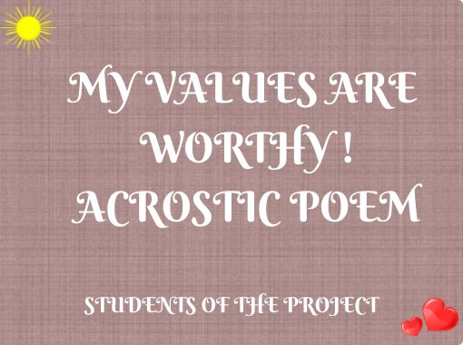

We prepared our quote magazine.

We prepared our quote magazine.
https://www.flipsnack.com/987BF577C6F/dergi-2/full-view.html

PROJECT POSTER

WE MADE A COLLABORATIVE POSTER USING WORDARTS CREATED BY OUR STUDENTS. WE USED POSTERMYWALL WEB.2 TOOL.

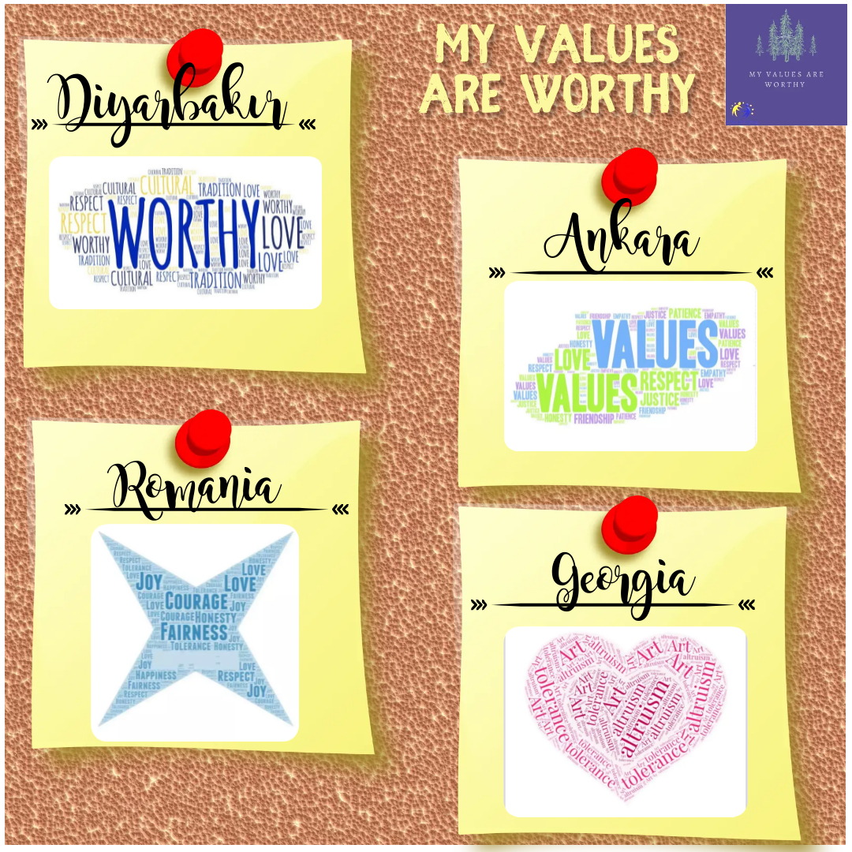

OUR LOGO

SOCIAL MEDIA

https://www.youtube.com/channel/UCWDVGS_7Z7IjmFmJ0HcfU9g
https://twitter.com/myvaluesarew
https://z-p15.www.instagram.com/my_values_are_worthy/

E-SAFETY DAY

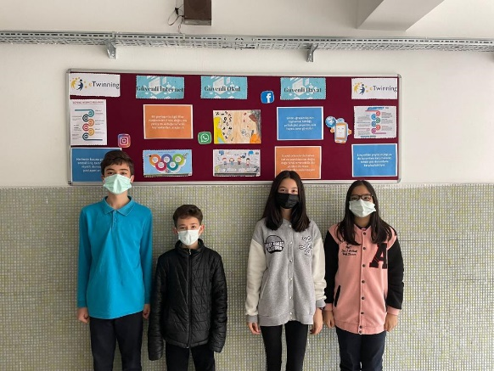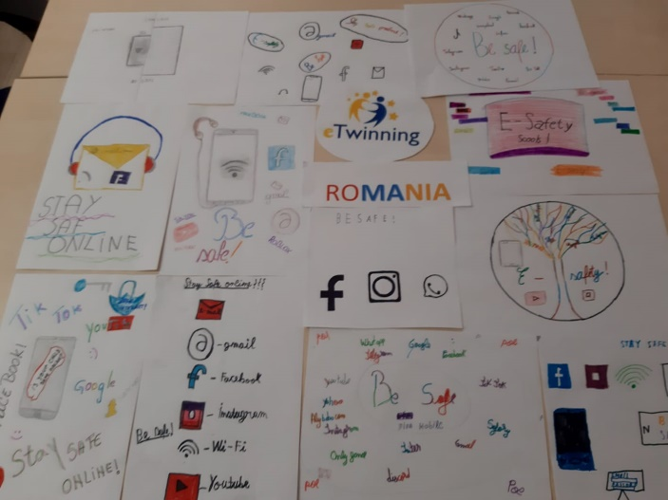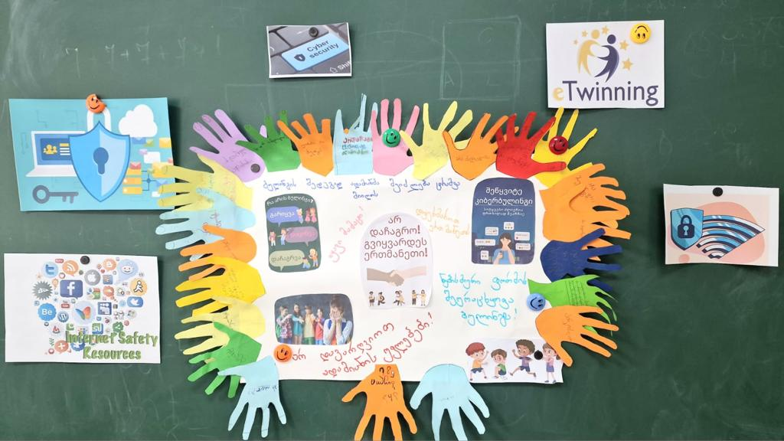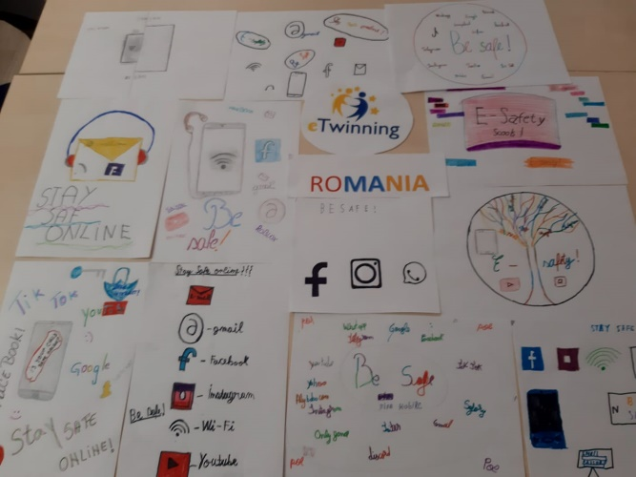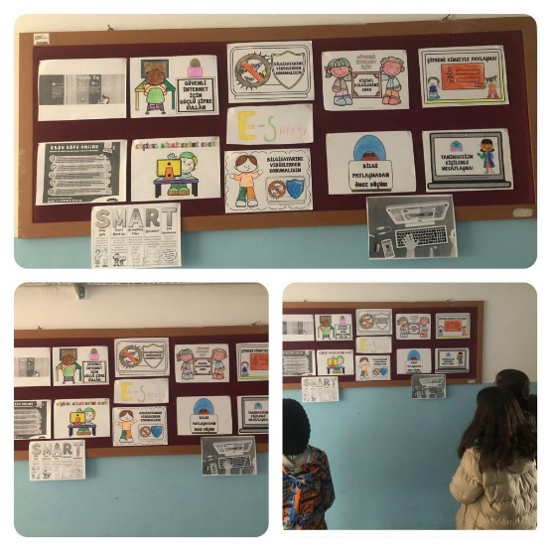

E-TWINNING DAY

WE CELEBRATED E-TWINNING DAY.

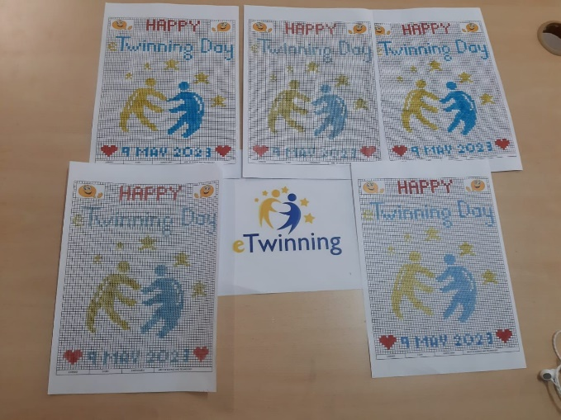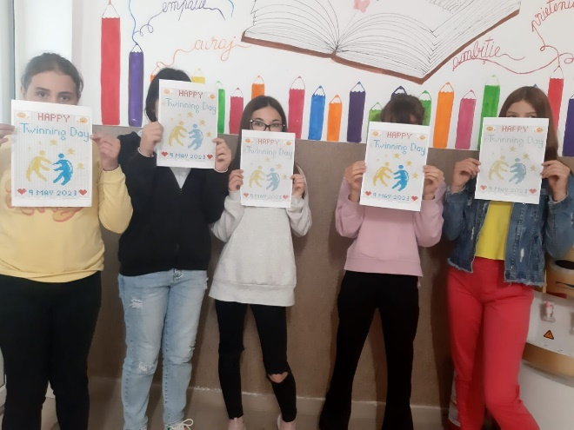
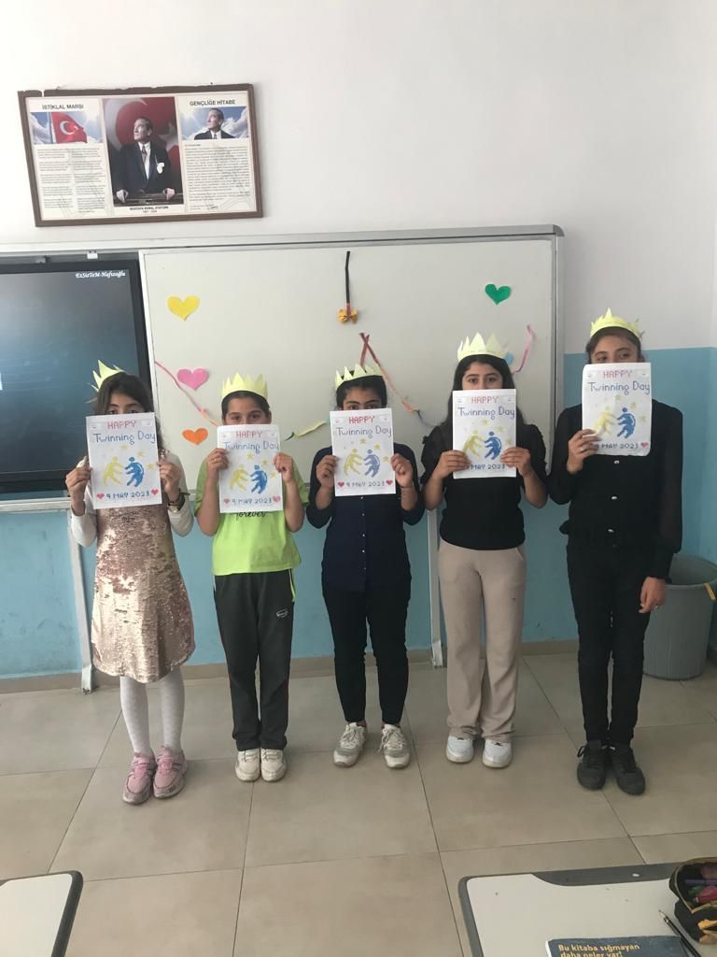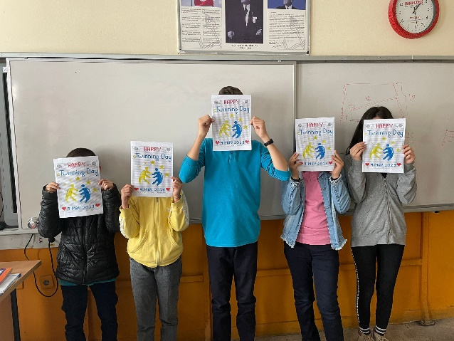

WORLD BOOK DAY- 23 APRIL

In world book day, we made bookmarks. Each country has added its own poetry words to these bookmarks. We distributed bookmarks to other schools, parents and students.

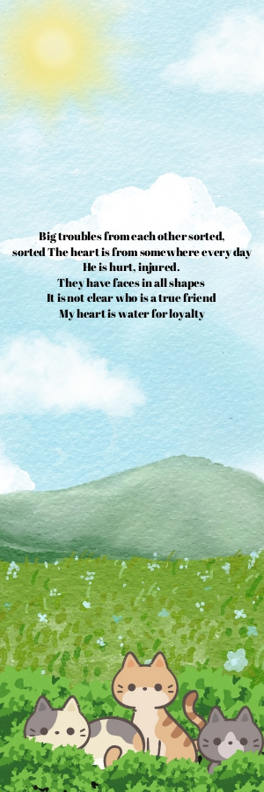

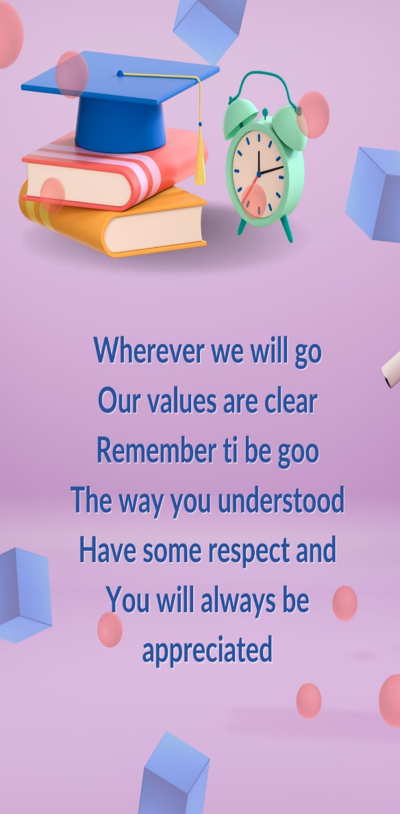

EVALUATION FORM (1st) & RESULTS- PUPILS= Before starting our project, we applied a questionnaire to the students. When we analyze the survey results, half of the students know values education and half do not. Most of the students are not familiar with web.2 tools. Most of the students do not know the root values in the curriculum and most of them have not participated in an e-twinning project before.

EVALUATION FORM (1st) & RESULTS- TEACHERS= Before starting our project, we applied a questionnaire to our teachers. Teachers are satisfied with the project content. They are confident that the project will increase student success. They believe that the project will improve them academically. Half of the teachers know web.2 tools and the other half know partially. Taking part in the project makes them happy.

EVALUATION FORM (2nd) & RESULTS- PUPILS= At the end of the project, we made a survey to the students. All of the students liked our project. Most of the students liked the Kahoot activity. As another team, they stated that they wish to be in the friendship-respect team. They said that values should not be forgotten over time. This project created awareness of values in them, they made new cultures and new friends thanks to the project. Some of them practiced their English thanks to this project. They learned about new web.2 tools and said that they will continue to use them.
EVALUATION FORM (2nd) & RESULTS- TEACHERS= At the end of the project, we made a survey to the teachers. Our teachers liked the project very much. They stated that the students' perspectives on values changed thanks to the project. They said that they were satisfied with the participation of their students in the project and that they learned about different cultures. They said that they believed they could get a quality label at the end of the project.
OUR FIRST MEETING WAS TEACHER MEETING. IN THIS MEETING, WE REVIEWED THE RENEWED ESEP PLATFORM. WE DISCUSSED THE OBJECTIVES AND ACTIVITIES OF OUR PROJECT.
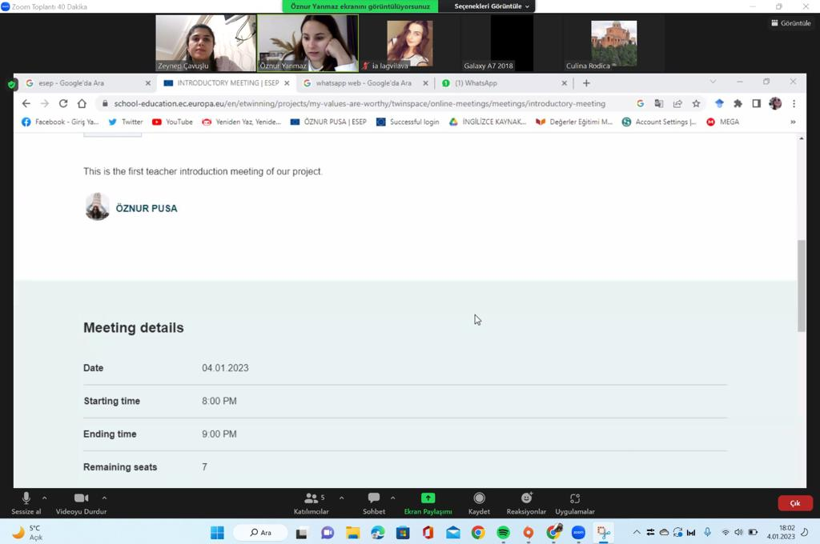
OUR SECOND MEETING WAS STUDENT MEETING. OUR STUDENTS MADE A SHORT INTRODUCTORY SENTENCE ABOUT THEIR OWNERS. THROUGH THIS MEETING, THEY GOT TO KNOW THEIRSELF. THEY TALKED ABOUT THINGS THEY HAVE DONE IN THE PROJECT.
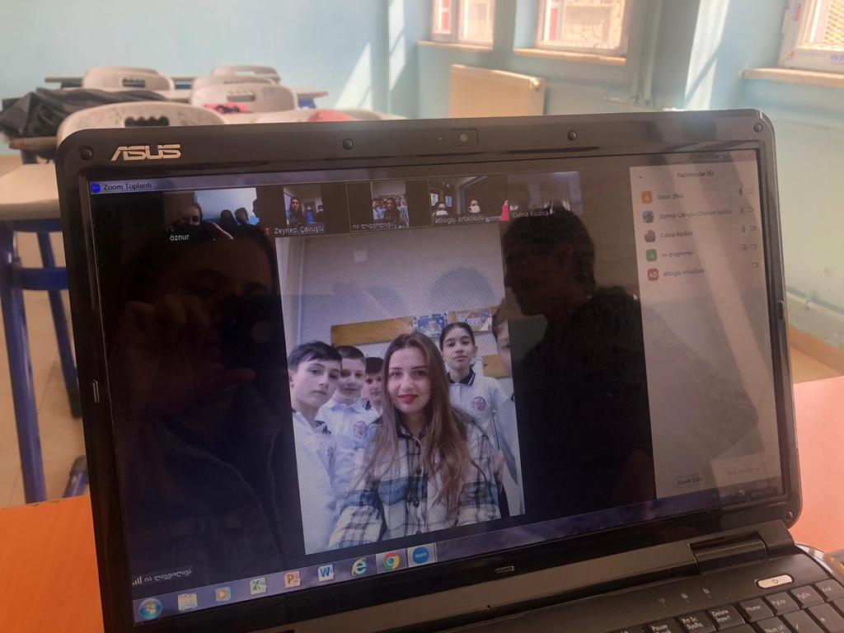
WE DID OUR END OF PROJECT EVALUATIONS IN OUR 3rd MEETING. WE STATED OUR FEELINGS AND THOUGHTS ABOUT THE PROJECT. THE STUDENTS STATED HOW IT WAS TO PARTICIPATE IN THE PROJECT. WE ENDED THE MEETING BY SAYING GOODBYE.

